Is your Sprinkler System Eligible for the Water Savvy Parkway Transformation Program?
Not eligible
If turning on the valve for your parkway sprinklers also activates your main lawn sprinklers, your property is not eligible (see example below).
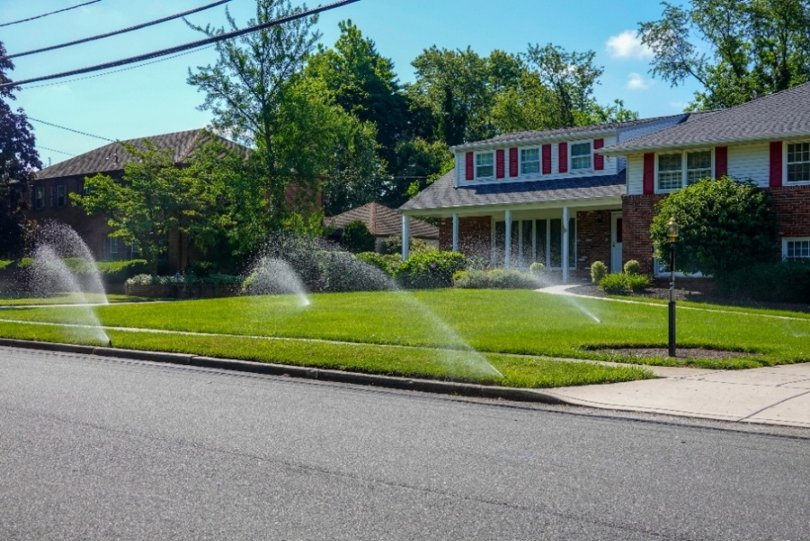

Eligible
If when your parkway sprinklers run or get turned on, and no other areas of your landscape have sprinklers running than this means your parkway is on its own sprinkler valve or watering zone and is eligible for this program.
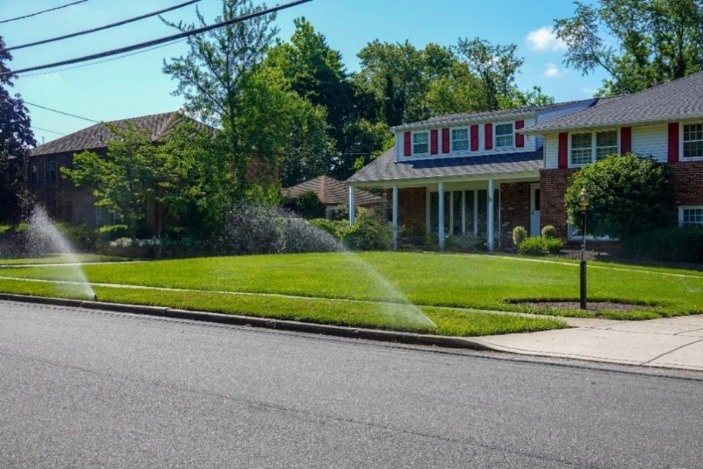

How do I check?
- Locate your sprinkler valves. (See picture below).
- Turn the top piece to the left ¼” to see which sprinklers turn on. Turn the top to the right to turn sprinklers off. (see video here) Manually Turning a Valve On and Off - Rain Bird Residential Valve Troubleshooting
